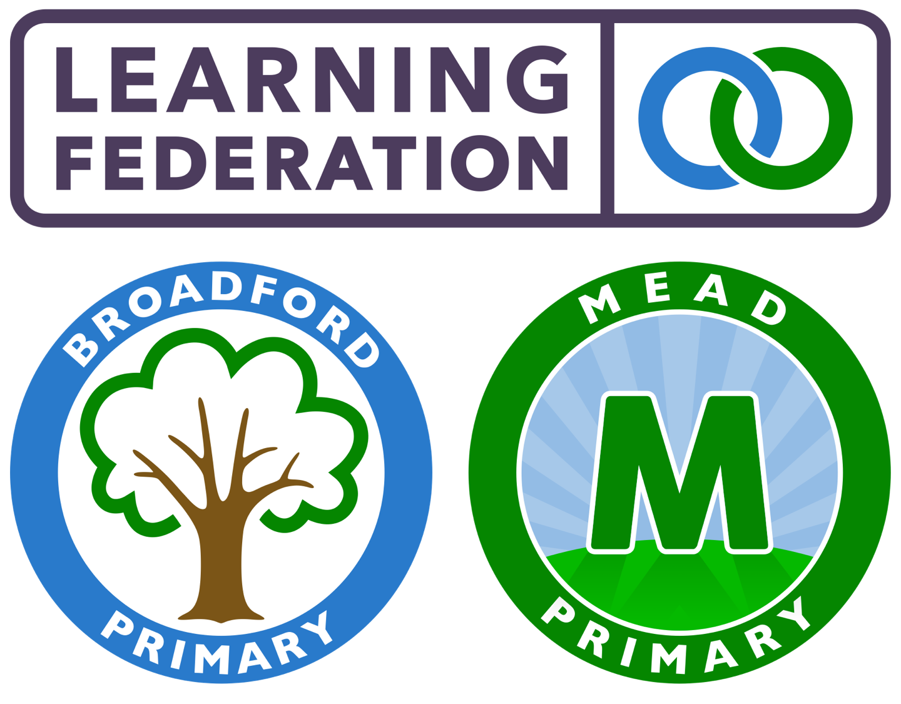

Term: Summer 2022

Dear parents and carers,

The aim of this newsletter is to give you an overview of the learning that will take place over the spring term in nursery.

The nursery blog on the school website and Facebook page are a great way to keep up to date with what is happening in the nursery, along with any upcoming events. It is very important for all parents to check the blog every Friday evening to know what is happening for your child. Please click under EYFS on the school website to view the Nursery blog.

This term the nursery themes will include: Minibeasts; People who Help Us; Pirates; and Underwater.

Below is an overview of the learning focuses for this term which supplement the Planning in The Moment approach to learning that the nursery follows.

Communication and Language
We will be encouraging the children to speak in full sentences to express themselves. Each term there will be focus texts which will allow the children to become familiar with the story and retell the story using their own words. This will also support them to increase their vocabulary and learn the meaning of new words.

Personal, Social and Emotional Development
This term the new starters will be settling into their new environment, ensuring they are aware of expectations and learning the routines within the setting. They will also be working on sharing resources and taking turns.

Those children who are more familiar with the setting will continue to develop positive relationships with their peers and to develop special friendships with other children. Opportunities for children to take on more responsibility such as taking leadership of an area of the provision for tidy up time will be offered. The children will also explore the zones of regulation, a whole school approach, through stories and during play.

Physical Development
This term there will be a continued focus on gross motor and coordination activities to strengthen the children’s shoulders and core muscles for whole body movements; this is a prerequisite to writing. They will also engage in fine motor activities such as: finger gym and name writing practice. They will be challenged to use one-handed tools and equipment, for example, making snips in paper with scissors as well as using a comfortable grip with good control when holding pens and pencils.

Maths
The children will be introduced to Ten Town this term to deepen their understanding of digits 0-10. Activities will include a focus around identifying numbers in their environment, representing numbers and learning to recognise more or less.

Literacy
Stories are a key part of our curriculum and high quality texts will be used throughout the day to foster the children’s love of reading. We will also be starting the Bedtime Story Scheme where your child can take 2 books home each week. A blog post will explain more about the reading scheme and the different ways in which you can share your love of reading with your children.

Mark making opportunities will be available throughout the provision. This term the children will also have a phonics phase 1 focus activity each week which will prepare them for phase 2 in reception.

Messy Play Continues
Messy play, or sensory play, is the term for any activities allowing children to work with their hands to create a controlled mess. Often involving traditionally messy ingredients such as paint, sand, slime, water, clay or mud, it is geared toward exploring feelings and imagination. Your child will have opportunities to participate in messy play on a daily basis; you will see some of these activities on the blog (and occasionally on their clothes!).

Independence
In nursery, independence will be promoted for your child and encouraged through the daily routines. These include: walking in independently; using their coat peg; self-registering; toileting; changing into wellies for the outside area; pouring water into their cups; and cleaning their cups. Please support your child by practicing putting on and taking off their socks and shoes at home, as well as their cardigans, jumpers and coats.

Key Dates
Check the blog on a weekly basis to keep up to date with key dates this year. We do not send letters home. We will send you an email regarding any upcoming Focus Child parent meetings.

Important information:

- Please ensure your child has a named set of spare clothes in nursery at all times.
- All uniform, cups and pack lunch boxes should be labelled with your child’s name.
- Please can toys from home stay at home. We have lots in school and it saves toys being lost or broken.
- Your child does not need to bring snacks to school. Fruit and water are available throughout the day for the children to access. The children only need to bring food to school if they are having a packed lunch.
- Please let the teachers know if your child has any medical needs, allergies or dietary requirements if you have not done so already.

We look forward to working with you over the upcoming term and thank you for your support. If you would like to contact a member of the nursery team via email, the address is: nursery@broadford.havering.sch.uk

Kind regards,
The Nursery Team

