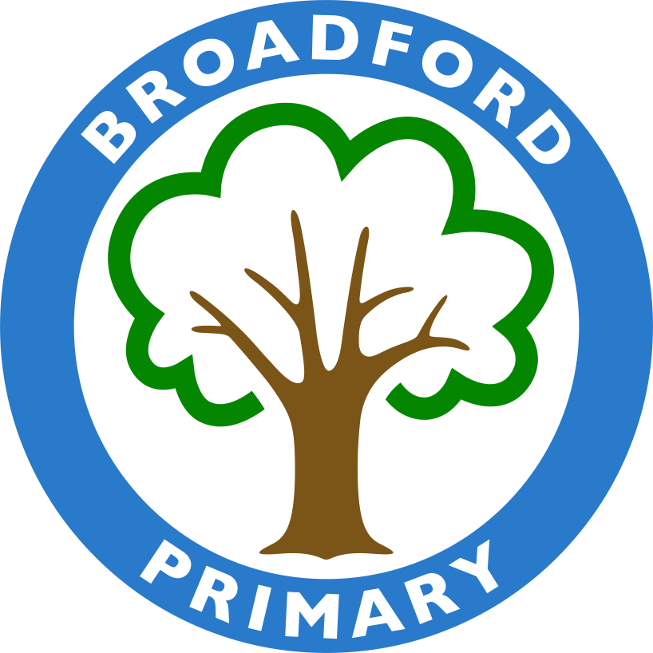

Headteacher: Mrs L Nicholls

Year 6 - Autumn Curriculum Newsletter
Friday 15th September 2023

Welcome back to school - we are so happy to see how enthusiastically the children have participated in their learning already and cannot wait to see how they flourish in their final year at Broadford.
Please find below some key information about the Autumn term and our expectations. Please do not hesitate to contact us if you have any queries using our inbox: year6@broadford.havering.sch.uk.

Homework:
Our expectation at Broadford is that every child should do the following every night:
● 15 minutes reading to themselves or an adult (signed in the reading record)
● 15 minutes practising spellings in their spelling book
● 15 minutes rehearsing times tables facts on Times Tables Rockstars

Mathletics:
All children should have received or already know their Mathletics information. This is an online platform that the children can use to further consolidate learning. This is monitored by the class teacher and children will be rewarded for the use of Mathletics at home. Please note however, this is not compulsory.

Spellings:
Spellings will be given out on Mondays. The children should practise their words every evening. Spelling books must be brought in on Fridays, which is also when the weekly test happens. This will be closely monitored.

P.E Lessons
For Tuesday afternoon, children can wear their PE kit to school for their lessons in the afternoon - black/grey/navy shorts or trousers and a white polo/t-shirt. Children must not wear tracksuits or any other colours than those listed above.

Forest School
This year all children will participate in Forest School, which will take place on Thursday afternoons.
For these sessions they will need to change into: long trousers, a waterproof coat and a pair of old shoes or wellies that can stay in school.
Please make sure that children have weather appropriate attire, so that they can fully enjoy the sessions, even on a rainy day!

School Uniform
It has been wonderful to see the Year 6 pupils return to school looking very smart in their school uniform. Please be reminded that the school colours are grey, black and navy. All school uniform is available through Premier School Wear. Children are permitted to wear stud earrings and must not wear nail varnish.

Reading Books
As reading is a huge priority here at Broadford, we will do our best to encourage the children to change their books regularly and every child will read 1:1 with an adult at least once a week. Please remind the children to let any adults know if they need to change their book and that it is their responsibility to bring any old reading books back to school.

105 Books to Read Before Leaving Broadford
Please be reminded of our new reading reward system, where each year pupils can read 15 quality stories and be rewarded with certificates and prizes. There will be three certificates to earn - bronze, silver and gold. The children will keep trackers in school to monitor the books they have read - please find all the key stage 2 trackers, along with the books they can read here. Please also note that some books have a gold star next to them indicating that the book can be reviewed using MyBookBlog.

Key Dates

Autumn 1 |  | Autumn 2
Tuesday 3rd October | School Trip to the British Museum | Monday 30th October | School closed - INSET day
Tuesday  17th & Wednesday  18th October | Parent Consultations | Tuesday 31st November | Children return to school
Friday 20th October | Last day of half term | Tuesday  7th November | Stay & Learn @ 2pm
 |  | Thursday  8th November | Into Film Festival - Westfield
 |  | Thursday  9th November | School Trip to Bedfords Park
 |  | Wednesday  6th December | Year 6 Carol Concert
 |  | Tuesday  19th December | Last day of Autumn term

Curriculum Information
We have included a summary of the topics which the children will be covering this term below, so that you can best support your child with their learning at home.

We look forward to the year ahead as the children embark on their final chapter of their primary school career.
Any questions please email - year6@broadford.havering.sch.uk

Yours faithfully,

Miss Betty Miss Bazid Miss Kenealy Ms Munnelly
Year 6 Lead Redwood Class Teacher Birch Class Teacher Larch Class Teacher
Autumn Term
 | 1st Half Term | 2nd Half Term
Literacy | We will be studying the book Holes by Louis Sachar. The children will practise writing a range of text types including: character & setting descriptions, a narrative piece, letters, a fact file, a non-chronological report and diary entries. | We will be studying legends and a version of Floodland. The children will practise writing a range of text types including: setting & character descriptions, a narrative from an alternative perspective and a persuasive speech
Maths | Place Value  Calculation - Four Operations | Calculation - Four Operations
It is essential for the children to know all of their Times Tables so that they can access the Mathematics curriculum in Year 6. Please encourage your child to practise on TTRockstars every evening to improve their speed and accuracy.
Here are some useful websites to support your child with their learning at home:
Corbett Maths Primary
Mathletics
Computing | Computing Systems and Networks | Creating Media
Science | Light | Electricity
History/  Geography | Ancient Greece | Six Grid Reference
RSE | Me & My Relationships | Valuing Difference
RE | Justice and poverty: Can religions help to build a fair world | What does it mean to be a Christian?
PE | Hockey | Gymnastics
Art/Design and Technology | Set Design & Shadow Puppets
French | Let’s visit a French town & Shopping | This is France

